**Harbor Health Clinics Patient Management System Design Report**

Hang Yang

SYS 5013: System Engineering Analysis

Prof. Hitam Zidan

Oct 10, 2024

**Introduction**

To implement an efficient and accurate data entry system for Harbor Health Clinics’ Patient Records Management, this design schema applies key data entry principles such as intuitive instructions, effective data capture, and precise field validations. By incorporating a logical sequence of fields, auto-fill options, and real-time feedback, the system not only enhances data accuracy but also streamlines the user experience. The interface is designed to guide users with clear prompts and immediate error messages, ensuring each entry adheres to the clinic's data standards. Combining keyboard inputs with checkbox options, the system captures necessary patient information swiftly and accurately, reducing administrative burden and minimizing the risk of errors. This approach supports Harbor Health Clinics in maintaining high-quality patient records while enabling staff to focus on delivering exceptional patient care.

**Layout Overview**

To create a user-friendly experience, I selected a consistent and intuitive layout with clearly labeled sections to ensure seamless navigation for users. The design focuses on field structure and validation rules to enhance accuracy and ease of use when logging patient records. The sections are organized in a logical sequence: 1) Patient Identification, 2) Medical History, and 3) Insurance and Contact Information. Each section's fields are arranged in a top-down order, guiding users step-by-step through the data entry process. Detailed explanations for each section are outlined below:

**Figure 1**

*First Page Section*

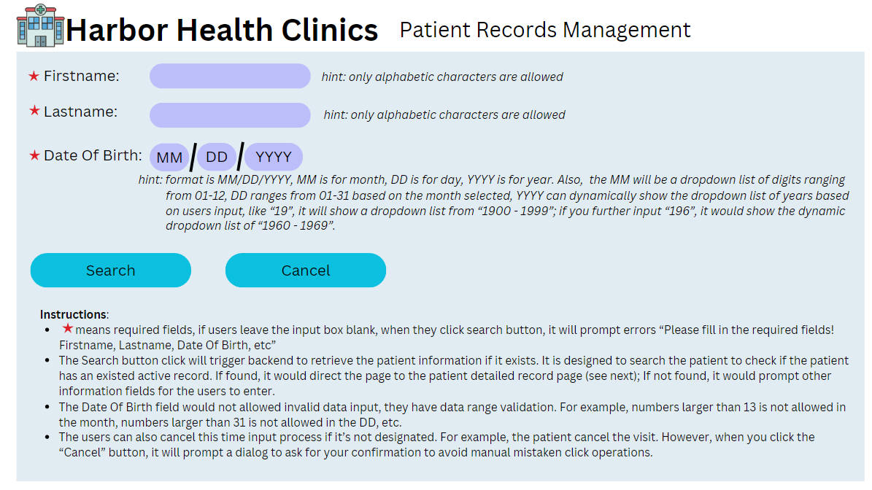

*Note*. picture by Hang Yang in 2024. Own work.

Fields included in this design are First Name, Last Name, Date of Birth. Validations are listed below:

* Names should only contain alphabetic characters.
* Date of Birth should follow the format MM/DD/YYYY, with drop-down lists for MM (01–12) and DD (01–31) to ensure validity.
* Year input dynamically shows relevant ranges to avoid errors (e.g., if a user starts with “19,” display 1900–1999).
* Required fields, with prompts if left empty.

**Figure 2**

*Medical History Section*

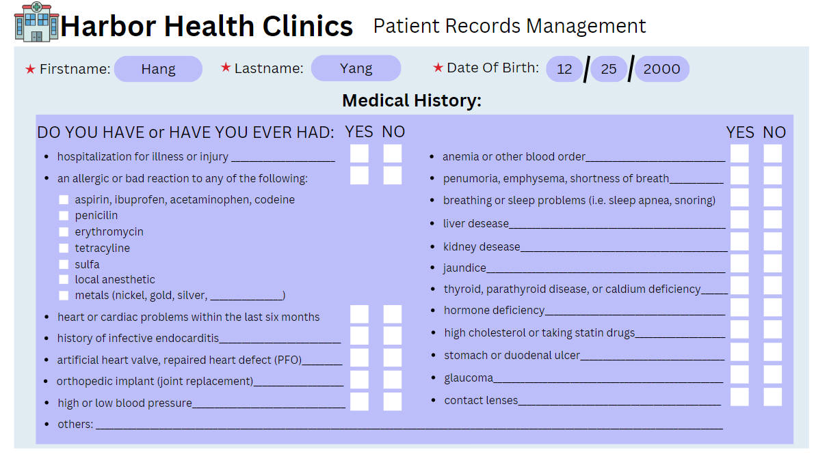

*Note*. picture by Hang Yang in 2024. Own work.

Fields in this Medical history form use various conditions (allergies, heart issues, etc.) with Yes/No checkboxes. Validations are listed below:

* Only one checkbox (Yes or No) should be selected for each item.
* For allergies requiring further details, allow additional text input (e.g., metals).
* Ensure logical sequence for conditions, allowing users to proceed only after completing all required fields).

**Figure 3**

*Insurance and Contact Section*

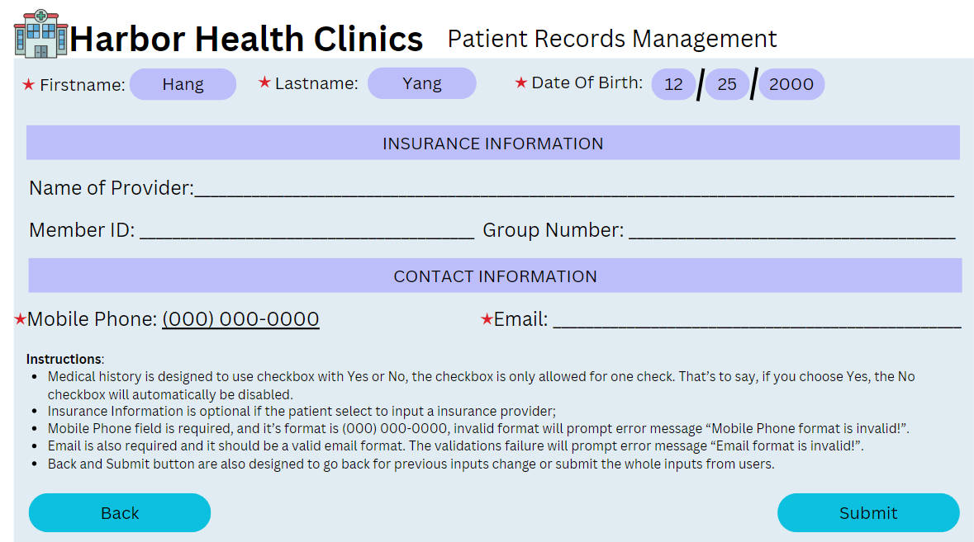

*Note*. picture by Hang Yang in 2024. Own work.

Fields are Name of Provider, Member ID, Group Number, Mobile Phone, Email. Validations are listed below:

* Phone number format validation: (000) 000-0000, with error prompts for incorrect formats.
* Email format validation for proper email structure (e.g., [user@example.com](mailto:user@example.com)).
* Insurance information is optional but follows strict format checks if entered.
* Both phone number and email fields are required for complete contact records.

**User Feedback Mechanisms**

We use instant validation feedback to display inline error messages next to fields that don’t meet validation requirements (e.g., “Email format is invalid!”). Also, green checkmarks is used for correctly filled fields and red warnings for errors. Predictive Text toolkit might also be integrated for common inputs, such as insurance provider names or medical conditions, by suggesting entries as users’ type. For known patient records, auto-fill data based on previous entries upon selecting their name and DOB, reducing redundant input. Display a success message or green outline on each section after validation. When the entire form is complete, a “Submission Successful, Thanks” confirmation appears.

**User Guidelines for Data Entry**

As stated above, our goal is to use the design explain itself, a.k.a, each field is aiming to be understandable by users with some basic instructions:

* Fields with a red asterisk (*) are mandatory.
* Follow input formats strictly. For instance, phone numbers must match the (000) 000-0000 format.
* Select either “Yes” or “No” for each medical condition. Double-check selections before proceeding to the next field.
* Use the “Search” function to retrieve existing records by entering First Name, Last Name, and Date of Birth. The system will auto-fill any matched records.

Quick Tips are:

* Utilize the drop-down menus for Date of Birth to reduce the risk of typing errors.
* Avoid special characters in name field as they only accept alphabetic characters.
* If you make an error, prompts will appear instantly to help you correct it.

**Conclusion**

This design plan emphasizes a streamlined, accurate, and user-friendly data entry process for Harbor Health Clinics. By implementing validation functions, such as regex for phone numbers and emails, and backend verification for data integrity, the system reduces input errors and ensures high-quality records. The approach combines keyboard-based inputs for text fields with checkboxes for simple Yes/No questions, enabling efficient data capture. Using a logical entry sequence, with real-time feedback and error prompts, the system guides users to correct errors instantly, reinforcing data accuracy. Additionally, the system design incorporates mixed data entry methods, predictive text, and auto-fill features to minimize redundancy and enhance speed. Dependent fields are dynamically disabled or enabled based on prior selections, and certain details are required only when relevant conditions are met, such as allergies. This user-focused, efficient flow minimizes clicks, enhances usability, and reduces the cognitive load on staff, allowing for a faster, more intuitive patient intake process. By leveraging effective coding practices and sequential data entry, Harbor Health Clinics can maintain data integrity while ensuring a smooth experience for staff, ultimately supporting high-quality patient care and streamlined administrative processes.

**References**

Nidiganti, V. (2019, February 12). 7 Tips to Improve Data Entry Process Significantly. Rely Services. <https://www.relyservices.com/blog/significant-improvement-of-data-entry-process>